EU Declaration of Conformity (DoC)

Hereby we,
Name of manufacturer: | DONGGUAN CITY MEICHENG SPORTING GOODS CO.,LTD
Address: | ROOM 802-3,BUILDING 26,TIANAN SHENCHUANGGU,NO.179,FENGGANG SECTION,DONGSHEN ROAD,FENGGAN TOWN,DONGGUAN CITY,GUANGDONG PROVINCE,CHINA
Zip code & City: | 523703 DONGGUAN
Country: | CHINA
Telephone number: | +86 13824395242

declare that this DoC is issued under our sole responsibility and that this product:
Product description: | BICYCLE HELMET
Type designation(s): | YC-15 M(55-58CM) & L(58-61CM)
Trademark:
Batch / Serial number:
Object of the declaration (further identification of the PPE allowing traceability; it may include a color image for the identification of the PPE):
……[ 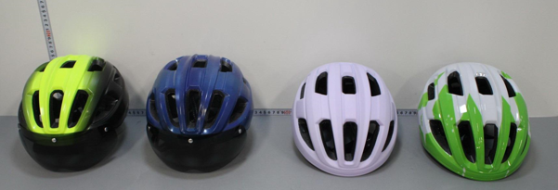]……

is in conformity with the relevant Union harmonization legislation:
Protective Product Equipment Regulation: (EU) 2016/425
and other Union harmonization legislation where applicable:

with reference to the following standards applied:
EN 1078:2012+A1:2012

The Notified Body Kiwa NL BV., with Notified Body number 0063 performed:
[choose applicable Modules: B ]

Where applicable:
The issued EU-type examination certificate: [252310144/AA/00]
The conformity assessment procedure (either conformity to type based on internal production control plus supervised product checks at random intervals (Module C2) or conformity to type based on quality assurance of the production process (module D)) under surveillance of notified body (name, number).

Additional information: (accessories)
.…………………………………………………………………………………………………………

Signed for and on behalf of:

_Dongguan 2025.5.19_ Huayong yang, General manager 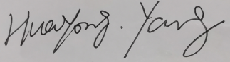___
Place and date of issue Name, Function, signature

